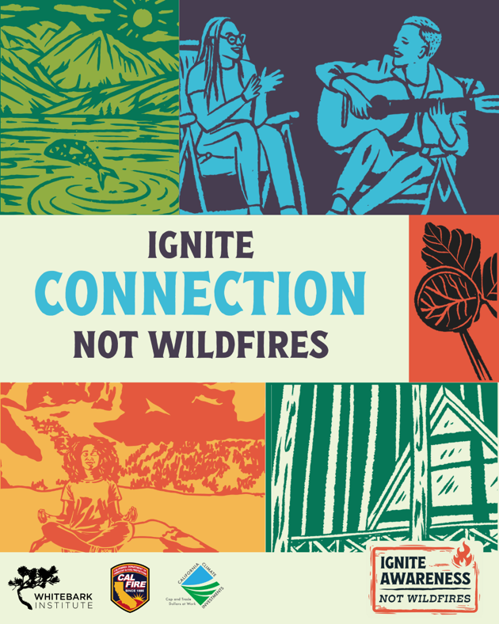

Ignite Connection, Not Wildfires
Campaign Run Dates: October 1, 2025- November 15, 2025
Link for Linktree or further educational info: www.whitebarkinstitute.org/igniteawareness
Thank you for sharing this regional wildfire prevention messaging! Below are recommended post captions – please use the ones that will resonate most with your audience. If you have any questions, please reach out to us! kristywilliams@mltpa.org or jackyates@mltpa.org.

Social Media Post Captions to Follow

Ignite Respect: General Captions

Respect General: Caption 1 (longer format)
The Eastern Sierra is more than a destination – it’s a home. 🌲
The open space and wild landscapes are an incredible backdrop for exploration, but they’re also home to communities, wildlife, and fragile ecosystems. One accidental ignition puts it all at risk.
When in the Eastern Sierra, treat it with care.

What can you do?
✅Opt out of a campfire and enjoy the stars.
✅ Check and respect fire restrictions before starting a fire or using a stove.
✅ Look for Red Flag Warnings
✅ Get a campfire permit if having a fire or using a stove or BBQ.
✅ Pack a fire extinguisher, shovel, and water when camping or off-roading.
✅ Ensure your campfire is cold before leaving. Drown, Stir, Repeat.
✅ Stay on Trails. Off-roading in dry vegetation can spark fires.
✅ Secure trailer chains to avoid creating sparks.
Ignite Respect, Not Wildfires.

Visit www.whitebarkinstitute.org/igniteawareness to learn more!

Funding for this project provided by the California Department of Forestry and Fire Protection’s Fire Prevention Program as part of the California Climate Investments Program

#IgniteAwareness #IgniteConnection #IgniteRespect #IgniteAdventure

Respect General: Caption 2 (shorter format)
The Eastern Sierra is more than a destination – it’s a home. 🌲
Its open landscapes are perfect for exploration, but also home to communities, wildlife, and ecosystems. One accidental ignition can put it all at risk.
Treat the Eastern Sierra with care.

What can you do?
✅Opt out of a campfire and enjoy the stars.
✅ Check and respect fire restrictions before starting a fire or using a stove.
✅ Look for Red Flag Warnings
✅ Get a campfire permit if having a fire or using a stove or BBQ.
✅ Pack a fire extinguisher, shovel, and water when camping or off-roading.
✅ Ensure your campfire is cold before leaving. Drown, Stir, Repeat.
✅ Stay on Trails. Off-roading in dry vegetation can spark fires.
✅ Secure trailer chains to avoid creating sparks
Ignite Respect, Not Wildfires.

Visit www.whitebarkinstitute.org/igniteawareness to learn more!

Funding for this project provided by the California Department of Forestry and Fire Protection’s Fire Prevention Program as part of the California Climate Investments Program

#IgniteAwareness #IgniteConnection #IgniteRespect #IgniteAdventure

Ignite Respect : Education Captions

Respect Education 1: Caption 1 Generations of Growth (longer format)
Generations of growth can be destroyed by a single spark. 🔥
Driving or parking on vegetation might seem harmless, but it can devastate the landscape. 🚗 And it’s not just tailpipes. Dragging chains, worn brakes, or even a loose trailer hitch can all spark a wildfire.
Sagebrush ignites easily and recovers slowly. Its oily leaves are fuel for wildfire, and a hot tailpipe could set it off. After a fire, sagebrush can take 20 to 50 years to recover – or may never return.
When sagebrush communities burn, invasive grasses can take over, creating a vicious cycle. These grasses are extremely flammable- they dry out early in the season, burn more frequently, and grow rapidly. This can push slow-growing sagebrush out for good. ⚠️

Love these sage communities? Treat them with care.
🚙 Park on pavement or dirt
⛓️ Secure trailer chains and gear
🌿 Avoid driving over vegetation
Ignite Respect, Not Wildfires.

Visit www.whitebarkinstitute.org/igniteawareness to learn more!

Funding for this project provided by the California Department of Forestry and Fire Protection’s Fire Prevention Program as part of the California Climate Investments Program

#IgniteAwareness #IgniteConnection #IgniteRespect #IgniteAdventure #ProtectSagebrush

Respect Education 1: Caption 2 Generations of Growth (shorter format)
Generations of growth can be destroyed by a single spark. 🔥
Driving or parking on vegetation might seem harmless, but it can devastate the landscape. 🚗🌿 And it’s not just tailpipes. Dragging chains, worn brakes, or even a loose trailer hitch can all spark a wildfire.
Sagebrush ignites easily and recovers slowly. A hot tailpipe could set it off and after a fire, sagebrush can take 20 to 50 years to recover – or may never return.
When sagebrush burns, invasive grasses take over, creating a vicious cycle. These grasses burn more often, pushing sagebrush out for good. ⚠️🌾
Love these sage communities? Treat them with care.
🚙 Park on pavement or dirt
⛓️ Secure trailer chains and gear
🌿 Avoid driving over vegetation

Visit www.whitebarkinstitute.org/igniteawareness to learn more!

Funding for this project provided by the California Department of Forestry and Fire Protection’s Fire Prevention Program as part of the California Climate Investments Program

#IgniteAwareness #IgniteConnection #IgniteRespect #IgniteAdventure #ProtectSagebrush

Respect Education 2: Caption 1 Habitat and Wildlife (longer format)
Wildfires threaten more than homes.
They often destroy important wildlife habitats. In the Eastern Sierra, sagebrush and forest ecosystems provide shelter and food for countless species. When wildfires spread unchecked, these habitats can be lost, impacting local wildlife.

🌿 What’s at Risk in High-Severity Wildfires?
Sagebrush ecosystems, which are not adapted to frequent, high-severity fires, face a serious threat. These landscapes are slow to recover and easily overtaken by invasive grasses that burn more frequently, preventing native species like the Bi-State Sage Grouse from returning.
Forested ecosystems also suffer long-term impacts. High-severity fire can remove canopy cover, disrupt migration corridors, and eliminate food sources for species like bears, pine marten, and bald eagles. These areas may take centuries to recover, if they return at all.
Reducing wildfire risk helps sustain the ecosystems that wildlife — and people — depend on.
Ignite Respect, Not Wildfires.

What can you do to prevent accidental ignitions? Learn more at www.whitebarkinstitute.org/igniteawareness

Funding for this project provided by the California Department of Forestry and Fire Protection’s Fire Prevention Program as part of the California Climate Investments Program

#IgniteAwareness #IgniteConnection #IgniteRespect #IgniteAdventure

Respect Education 2: Caption 2 Habitat and Wildlife (shorter format)
Wildfires threaten more than homes — they put entire ecosystems at risk.
In the Eastern Sierra, sagebrush and forested landscapes support wildlife like the Bi-State Sage Grouse and mule deer. But high-severity wildfires can wipe out these habitats.
🌿 Sagebrush isn’t adapted to frequent fire and recovers slowly — often replaced by invasive grasses.
🌲 Forest fires can remove food, shelter, and migration corridors, with recovery taking decades or longer.
Reducing wildfire risk means supporting the land — and all who depend on it.
Ignite Respect, Not Wildfires.

Visit www.whitebarkinstitute.org/igniteawareness to learn more!

Funding for this project provided by the California Department of Forestry and Fire Protection’s Fire Prevention Program as part of the California Climate Investments Program
#IgniteAwareness #IgniteConnection #IgniteRespect #IgniteAdventure

Respect Education 3: Caption 1 Cultural History (longer format)
The Eastern Sierra is more than just a destination – it’s a home. Accidental ignitions put landscapes, histories, and entire communities at risk.
What’s at stake:
- Cultural & Historic Sites: Home to Indigenous communities for thousands of years, wildfires threaten important artifacts and traditions tied to this land.
- Homes & Communities: In the Eastern Sierra, wildlands meet neighborhoods. A wildfire doesn’t just burn trees – it can devastate homes and communities. 🏡
🚫 Prevent accidental wildfires – follow fire restrictions and speak up when you see risky fire behavior.
Ignite Respect, Not Wildfires.

Visit www.whitebarkinstitute.org/igniteawareness to learn more!

Funding for this project provided by the California Department of Forestry and Fire Protection’s Fire Prevention Program as part of the California Climate Investments Program.

#IgniteAwareness #IgniteConnection #IgniteRespect #IgniteAdventure

Respect Education 3: Caption 2 Cultural History (shorter format)
The Eastern Sierra is more than just a destination – it’s a home. Accidental ignitions put landscapes, histories, and entire communities at risk.
What’s at stake:
- Cultural & Historic Sites: Home to Indigenous communities for thousands of years, wildfires threaten important artifacts and traditions.
- Homes & Communities: In the Eastern Sierra, wildlands meet neighborhoods. A wildfire doesn’t just burn trees – it can devastate homes and communities. 🏡
🚫 Prevent accidental wildfires – follow fire restrictions and speak up when you see risky fire behavior.
Ignite Respect, Not Wildfires.

Visit www.whitebarkinstitute.org/igniteawareness to learn more!

Funding for this project provided by the California Department of Forestry and Fire Protection’s Fire Prevention Program as part of the California Climate Investments Program
#IgniteAwareness #IgniteConnection #IgniteRespect #IgniteAdventure

