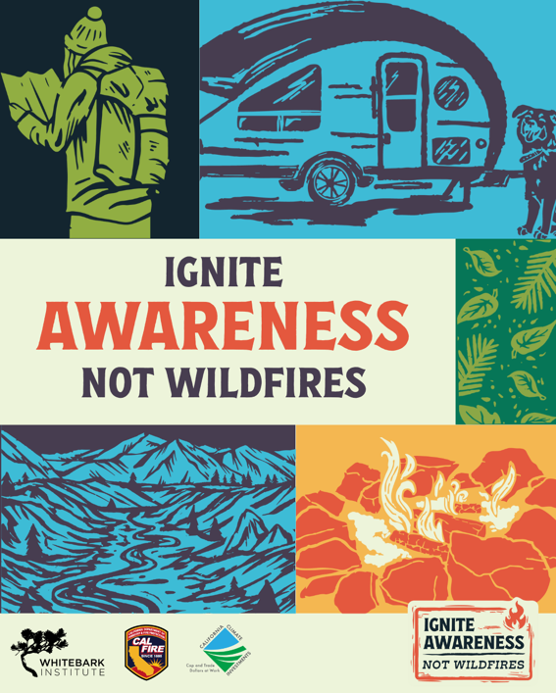

Ignite Awareness, Not Wildfires
Campaign Run Dates: May 3 – June 13, 2025 (OK to post after this timeframe)
Link for Linktree or further educational info: www.whitebarkinstitute.org/igniteawareness
Thank you for sharing this regional wildfire prevention messaging! Below are recommended post captions – please use the ones that will resonate most with your audience. If you have any questions, please reach out to us! kristywilliams@mltpa.org or jackyates@mltpa.org.

Social Media Post Captions to Follow

Ignite Awareness: General

Awareness General: Caption 1 (longer format)
In the Eastern Sierra, wildfire risk is real and rising. With hotter, drier summers, high winds, and fire-prone landscapes, it doesn’t take much to start a blaze. Nearly all wildfires in California are human-caused, which means we all have a role to play in preventing them.
Whether you’re camping, hiking, driving, or doing yard work, your actions matter. A single spark can threaten homes, habitats, and the landscapes we love.
Ignite Awareness, Not Wildfires is your starting point for understanding local wildfire risk and your role in reducing it. Learn what makes the Eastern Sierra uniquely at risk and how you can reduce that risk with every choice you make.
Follow along to explore fire conditions, local history, and smart steps you can take to help keep this place healthy and wildfire resilient.
Ignite Awareness, Not Wildfires.
Visit www.whitebarkinstitute.org/igniteawareness to learn more!
Funding for this project provided by the California Department of Forestry and Fire Protection’s Fire Prevention Program as part of the California Climate Investments Program
#IgniteAwareness #IgniteConnection #IgniteRespect #IgniteAdventure

Awareness General: Caption 1 (shorter format)
Wildfire risk is rising in the Eastern Sierra—and nearly all wildfires in California are human-caused. Whether you’re out exploring or working around your home, your actions matter. Ignite Awareness, Not Wildfires is your guide to understanding local risk and how you can help keep this place wildfire resilient. Follow along to explore fire conditions, local history, and smart steps you can take to help keep this place healthy and resilient.
Funding for this project provided by the California Department of Forestry and Fire Protection’s Fire Prevention Program as part of the California Climate Investments Program
#IgniteAwareness #IgniteConnection #IgniteRespect #IgniteAdventure

Ignite Awareness: Education

Awareness Education 1: Caption 1 Surprising Causes of Wildfire (longer format)
🔥In the dry and windswept Eastern Sierra wildfire risk runs high, and campfires aren’t the only source of accidental ignitions.
Anything that can create a spark can start a wildfire, sometimes in surprising ways. 💥
⚡ A lawnmower striking a rock sends a spark into nearby shrubbery.
🚗 A vehicle’s hot tailpipe ignites dry grass underneath it.
⛓️ Dragging trailer chains spark a fire along highways without the driver even knowing.
The good news is that these types of fires can be prevented! 🚫🔥
Ignite Awareness, Not Wildfires.
Want to help prevent the next wildfire? Visit www.whitebarkinstitute.org/igniteawareness to learn more.
Funding for this project provided by the California Department of Forestry and Fire Protection’s Fire Prevention Program as part of the California Climate Investments Program
#IgniteAwareness #IgniteConnection #IgniteRespect #IgniteAdventure

Awareness Education 1: Caption 2 Surprising Causes of Wildfire (shorter format)
🚨🔥 What do flat tires, toilet paper, tailpipes, and lawnmowers have in common? They’ve all started wildfires. 🌲💥 Anything that can create a spark can start a wildfire, sometimes in surprising ways.
We can all do our part to prevent accidental ignitions. Want to prevent the next wildfire? Learn more at www.whitebarkinstitute.org/igniteawareness
Ignite Awareness, Not Wildfires.
Funding for this project provided by the California Department of Forestry and Fire Protection’s Fire Prevention Program as part of the California Climate Investments Program.
#IgniteAwareness #IgniteConnection #IgniteRespect #IgniteAdventure

Awareness Education 2: Caption 1 Good Fire (longer format)
🌲 California’s forests have burned for thousands of years, with beneficial fires ignited by lightning and indigenous communities, keeping the land healthy and thriving.
Today, we face the consequences of a warmer, drier climate and a century of mismanagement that suppressed these vital fires. 🌍🔥
Not all fires are bad. Timing is everything. The right fire, at the right time, under the right conditions, can restore balance to our landscapes. But with vulnerable communities and ecosystems, the wrong spark can lead to catastrophic wildfires.
What can you do to help bring back good fire?
✅Learn about fuels reduction efforts in our area
✅ Support prescribed burns
✅ Prevent accidental ignitions from campfires, vehicles, OHVs, & debris burning
✅ Check and respect fire restrictions

Learn more at www.whitebarkinstitute.org/igniteawareness

Ignite Awareness, Not Wildfires.

Funding for this project provided by the California Department of Forestry and Fire Protection’s Fire Prevention Program as part of the California Climate Investments Program
#IgniteAwareness #IgniteConnection #IgniteRespect #IgniteAdventure

Awareness Education 2: Caption 2 Good Fire (shorter format)
🌲 California’s forests have burned for thousands of years with beneficial fires, ignited by lightning and indigenous communities, keeping the land healthy.
Today, climate change and a history of mismanagement have suppressed these vital fires. 🌍🔥
Not all fires are bad- timing is key. The right fire can restore balance, but the wrong spark can lead to catastrophic wildfires.
What can you do to help bring back good fire?
✅Learn about fuels reduction efforts in our area
✅ Support prescribed burns
✅ Prevent accidental ignitions
✅ Check and respect fire restrictions
Ignite Awareness, Not Wildfires.
Funding for this project provided by the California Department of Forestry and Fire Protection’s Fire Prevention Program as part of the California Climate Investments Program
#IgniteAwareness #IgniteConnection #IgniteRespect #IgniteAdventure

Awareness Education 3: Caption 1 Wildfire risk is year-round (longer format)
🔥 Don’t let cool temperatures fool you—wildfire season is year-round in the Eastern Sierra. 🌲
Some of the most destructive fires in this region have actually occurred in winter. The Eastern Sierra faces a high wildfire risk due to:
💨 High Winds – They can drive wildfires and spread embers for miles.
💧 Low Humidity – The Sierra Nevada rain shadow creates less precipitation and dry air.
🌾 Dry, Fire-Prone Vegetation – Not just trees—sagebrush and grasses are highly flammable, and invasive plants can make things worse.
While wildfire risk is always present, certain conditions make that risk even higher. Just because fire restrictions aren’t in place doesn’t mean it isn’t risky to have a campfire. Always check Red Flag warnings and fire weather alerts—when in doubt, opt out.
Ignite Awareness, Not Wildfires.
Learn more about how you can prevent accidental ignitions at www.whitebarkinstitute.org/igniteawareness
Funding for this project provided by the California Department of Forestry and Fire Protection’s Fire Prevention Program as part of the California Climate Investments Program
#IgniteAwareness #IgniteConnection #IgniteRespect #IgniteAdventure #WildfireSafety #EasternSierra #FirePrevention #RedFlagWarnings

Awareness Education 3: Caption 2 Wildfire risk is year-round (shorter format)
🔥 Don’t let cool temperatures fool you—wildfire season is year-round in the Eastern Sierra. 🌲
Even in winter, the Eastern Sierra faces a high wildfire risk due to:
💨 High Winds
💧 Low Humidity
🌾 Dry, Fire-Prone Vegetation
Even if fire restrictions aren’t in place, it doesn’t mean campfires are risk-free. Always check Red Flag warnings and fire weather alerts—when in doubt, opt out.
Ignite Awareness, Not Wildfires.
Learn more about how you can prevent accidental ignitions at www.whitebarkinstitute.org/igniteawareness
#IgniteAwareness #IgniteConnection #IgniteRespect #IgniteAdventure
Funding for this project provided by the California Department of Forestry and Fire Protection’s Fire Prevention Program as part of the California Climate Investments Program

