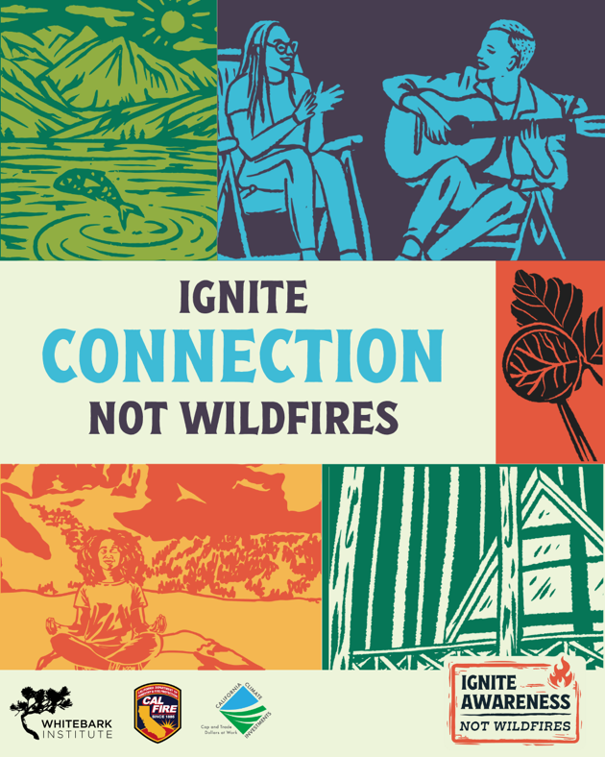

Ignite Connection, Not Wildfires
Campaign Run Dates: August 9, 2025- September 5, 2025
Link for Linktree or further educational info: www.whitebarkinstitute.org/igniteawareness
Thank you for sharing this regional wildfire prevention messaging! Below are recommended post captions – please use the ones that will resonate most with your audience. If you have any questions, please reach out to us! kristywilliams@mltpa.org or jackyates@mltpa.org.

Social Media Post Captions to Follow

Ignite Connection: General:

Connection General: Caption 1 (longer format)
In the Eastern Sierra, resilience begins with connection to the land, to one another, and to the places we call home (whether for a weekend or a lifetime).

Ignite Connection is a call to tune in to the community that surrounds us, the watersheds that sustain us, and to the forests and valleys that shape this place.

✨ Stay curious. Learn about local landscapes and the risks they face.
✨ Talk with your neighbors. Create defensible space together.
✨ Learn about and support fuels reduction work.
✨ Recognize that your actions in fire prevention ripple outward.

Ignite Connection, Not Wildfires.
Want to build fire adapted communities? Visit www.whitebarkinstitute.org/igniteawareness to learn more!
Funding for this project provided by the California Department of Forestry and Fire Protection’s Fire Prevention Program as part of the California Climate Investments Program
#IgniteAwareness #IgniteConnection #IgniteRespect #IgniteAdventure #WildfirePreparedness #CommunityResilience #EasternSierra #DefensibleSpace

Connection General: Caption 2 (shorter format)
In the Eastern Sierra, resilience starts with connection — to the land, to each other, and to the places we love. Ignite Connection invites you to tune into the forests, valleys, and watersheds that sustain us all.

✨ Learn about the land and wildfire risk
✨ Team up with neighbors to reduce fuels
✨ Recognize that your choices in fire prevention ripple outward

Ignite Connection, Not Wildfires.
Want to build fire adapted communities? Visit www.whitebarkinstitute.org/igniteawareness to learn more!
Funding for this project provided by the California Department of Forestry and Fire Protection’s Fire Prevention Program as part of the California Climate Investments Program
#WildfirePreparedness #CommunityResilience #EasternSierra #DefensibleSpace #IgniteAwareness #IgniteConnection #IgniteRespect #IgniteAdventure

Ignite Connection: Education

Connection Education 1: Caption 1 Defensible Space (longer format)
🌍🔥 Wildfire Resilience is a Community Effort – We all have a role to play.

🔥🌲 Living in the Eastern Sierra comes with a higher risk of wildfire. We’ll always live with the threat of wildfires, so preparation is key. 💪. One of the most effective things you can do to reduce wildfire risk is create defensible space, starting right at your foundation.

There are three key zones to focus on, and Zone 0 is your first line of defense.

🏡 Zone 0 (0–5 feet from your home): This is your ember-resistant zone. It’s where most home ignitions start — from wind-blown embers.
✅ Remove anything flammable: wood mulch, dead leaves, firewood, and even flammable plants
✅ Keep this area clear and lean — or better yet, non-combustible (like gravel or stone)
✅ Use ember-resistant vents and install metal mesh to keep embers out

🌿 Zone 1 (5–30 feet):
Clear dead vegetation, trim tree branches at least 10 feet from other trees and your roofline, and keep grasses low.

🌲 Zone 2 (30–100+ feet):
Thin trees and shrubs, reduce fuel loads, and maintain space between plants so fire doesn’t spread easily.

Creating defensible space doesn't mean stripping your yard — it means managing it with wildfire in mind. When we take action at home, we build stronger, more connected communities.
Ignite Connection, Not Wildfires.
Want to build fire adapted communities? Visit www.whitebarkinstitute.org/igniteawareness to learn more!
Funding for this project provided by the California Department of Forestry and Fire Protection’s Fire Prevention Program as part of the California Climate Investments Program
#WildfirePreparedness #CommunityResilience #EasternSierra #DefensibleSpace #IgniteAwareness #IgniteConnection #IgniteRespect #IgniteAdventure

Connection Education 1: Caption 2 Defensible Space (shorter format)
🔥🌲 Wildfire risk is part of the landscape in the Eastern Sierra , but preparation can make all the difference. One of the best ways to reduce risk is by creating defensible space, starting with Zone 0 (0-5 feet from your home).
🏡 Zone 0:
✅ Remove flammable materials (mulch, leaves, wood)
✅ Keep it clear and lean or non-combustible like gravel
✅ Use ember-resistant vents
🌿 Zone 1 (5-30 ft) & 🌲 Zone 2 (30-100+ ft):
Clear dead vegetation, trim trees, and thin shrubs to reduce fuel loads and slow fire spread.
Building defensible space is about smart, fire-aware landscaping. When we prepare, we strengthen our communities.

Ignite Connection, Not Wildfires.
Want to build fire adapted communities? Visit www.whitebarkinstitute.org/igniteawareness to learn more!

Funding for this project provided by the California Department of Forestry and Fire Protection’s Fire Prevention Program as part of the California Climate Investments Program
#WildfirePreparedness #CommunityResilience #EasternSierra #DefensibleSpace #IgniteAwareness #IgniteConnection #IgniteRespect #IgniteAdventure

Connection Education 2: Caption 1 Watershed health (longer format)
Whether you're a visitor or resident of the Eastern Sierra, we're all connected to this beautiful landscape. 🌲
The Sierra Nevada snowpack sustains not only local communities but also serves as California’s largest reservoir, providing water to 60% of the state. Our health and well-being are directly tied to the health of these watersheds and the forests they support.
That’s why reducing fire risk here is crucial — not only for the local ecosystems and communities but for everyone downstream.

What can you do to prevent wildfire?
✅Opt out of a campfire and enjoy the stars.
✅ Check and respect fire restrictions before starting a fire or using a stove.
✅ Look for Red Flag Warnings.
✅ Get a campfire permit if having a fire or using a stove or BBQ.
✅ Pack a fire extinguisher, shovel, and water when camping or off-roading.
✅ Ensure your campfire is cold before leaving. Drown, Stir, Repeat.
✅ Stay on Trails. Off-roading in dry vegetation can spark fires.
✅ Secure trailer chains to avoid creating sparks.
Ignite Connection, Not Wildfires.

Visit www.whitebarkinstitute.org/igniteawareness to learn more!

Funding for this project provided by the California Department of Forestry and Fire Protection’s Fire Prevention Program as part of the California Climate Investments Program
#IgniteAwareness #IgniteConnection #IgniteRespect #IgniteAdventure

Connection Education 2: Caption 2 Watershed health (shorter format)
Whether you're a visitor or resident, we’re all connected to the Eastern Sierra’s landscape. 🌲 The Sierra Nevada snowpack sustains local communities and much of California, providing water to 60% of the state. Protecting these watersheds from wildfire is crucial for everyone, including those downstream.
Prevent wildfires with these simple steps:
✅Opt out of a campfire and enjoy the stars.
✅ Check and respect fire restrictions before starting a fire or using a stove.
✅ Look for Red Flag Warnings.
✅ Get a campfire permit if having a fire or using a stove or BBQ.
✅ Pack a fire extinguisher, shovel, and water when camping or off-roading.
✅ Ensure your campfire is cold before leaving. Drown, Stir, Repeat.
✅ Stay on Trails. Off-roading in dry vegetation can spark fires.
✅ Secure trailer chains to avoid creating sparks.
Ignite Connection, Not Wildfires.

Visit www.whitebarkinstitute.org/igniteawareness to learn more!

Funding for this project provided by the California Department of Forestry and Fire Protection’s Fire Prevention Program as part of the California Climate Investments Program
#IgniteAwareness #IgniteConnection #IgniteRespect #IgniteAdventure

Connection Education 3: Caption 1 Say something (longer format)
Little actions can make a huge difference if the whole community acts together.
If you see something that doesn’t look right- an abandoned campfire left smoldering or smoke in the distance- don't pass it by. Your actions could make all the difference.

If you have the resources, make sure that campfire is dead out, or reach out for help.
If you spot smoke or flames, report them immediately to 911 or an on-duty ranger or camp host. Early detection is crucial in preventing large wildfires and reducing risk in our forests.

Ignite Connection, Not Wildfires.
Visit www.whitebarkinstitute.org/igniteawareness to learn more!

Funding for this project provided by the California Department of Forestry and Fire Protection’s Fire Prevention Program as part of the California Climate Investments Program
#IgniteAwareness #IgniteConnection #IgniteRespect #IgniteAdventure

Connection Education 3: Caption 2 Say something (shorter format)
Small actions matter — especially when we act together.
If you see an abandoned campfire or smoke in the distance, don’t ignore it.
Put it out if you can, or report it to 911 or a ranger. Early action helps reduce wildfire risk.
Ignite Connection, Not Wildfires.
Visit www.whitebarkinstitute.org/igniteawareness to learn more!
Funding for this project provided by the California Department of Forestry and Fire Protection’s Fire Prevention Program as part of the California Climate Investments Program
#IgniteAwareness #IgniteConnection #IgniteRespect #IgniteAdventure

